Gryffindors Begin Here

[Hold your phone or tablet, with the Aurasma app open, over the crest to begin]

HINT: You’ll be starting on the 2nd floor.

Hufflepuffs Begin Here

[Hold your phone or tablet, with the Aurasma app open, over the crest to begin]

HINT: You’ll be starting on the 2nd floor.

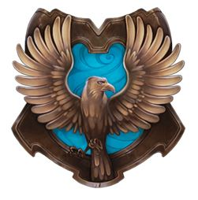

Ravenclaws Begin Here

[Hold your phone or tablet, with the Aurasma app open, over the crest to begin]

HINT: You’ll be starting on the 1st floor.

Slytherins Begin Here

[Hold your phone or tablet, with the Aurasma app open, over the crest to begin]

HINT: You’ll be starting on the 2nd floor.

